NAME BADGE REQUEST FOR OSU–OKLAHOMA CITY
Return form to Print & Mail Services at printandmail@osuokc.edu.

NAME: NAME:
TITLE: TITLE:
DEPT.: DEPT.:

NAME: NAME:
TITLE: TITLE:
DEPT.: DEPT.:

NAME: NAME:
TITLE: TITLE:
DEPT.: DEPT.:

COLOR: ORANGE W/ BLACK SILVER W/ BLACK WHITE W/ BLACK

OPTIONS: 3 LINES 1 LINE

BACKING: All name badges include a magnetic back, unless otherwise requested.

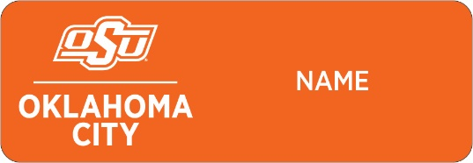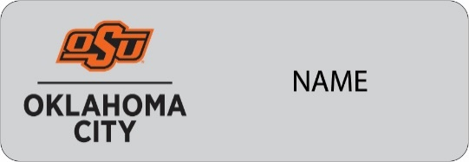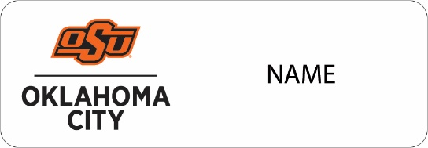

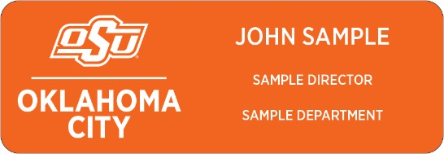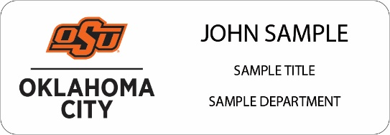

REQUESTED BY: PHONE #:

SUPERVISOR SIGNATURE:

DEPARTMENT HEAD SIGNATURE:

DEPARTMENT NAME:

ACCOUNT NUMBER: DATE:

For special customization, please contact printandmail@osuokc.edu.

