How to Select Training for Self or Assign Training

- Enter my.okstate.edu and click the employee tab. You will find the Talent Management System link towards the bottom of the links. Choose the Learning icon or hover over the Learning tab and select Browse for Training.

- From here you can browse all classes by subject, date range, or type. You can also review titles from the Talent Management Catalog and enter the name in the search field.

Online | Instructor-Led | Curriculum | Material

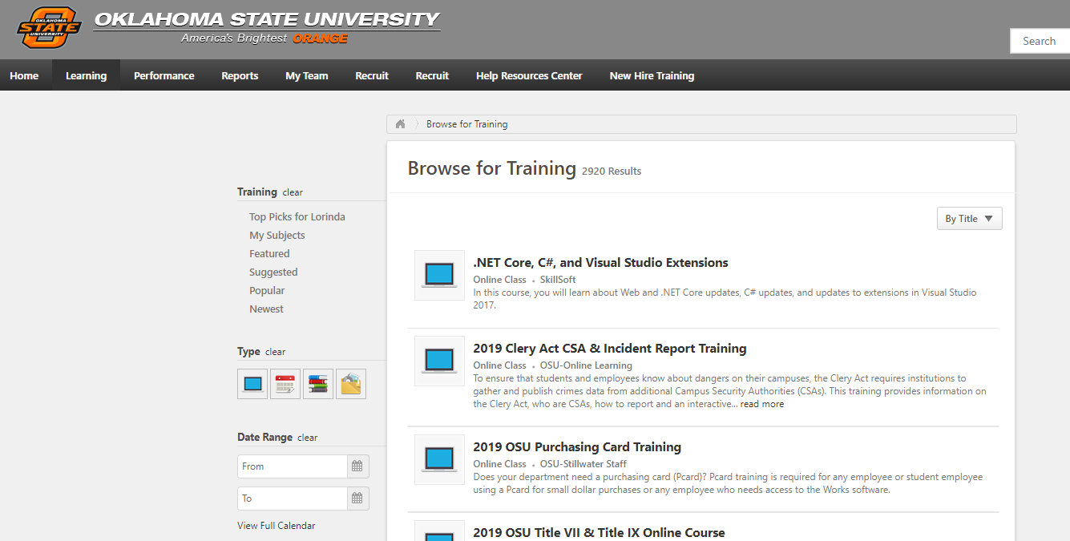

- When you are searching for a course, click on the title. You will click Launch for your own trainings. You can click the Assign button to assign the training to a subordinate employee.
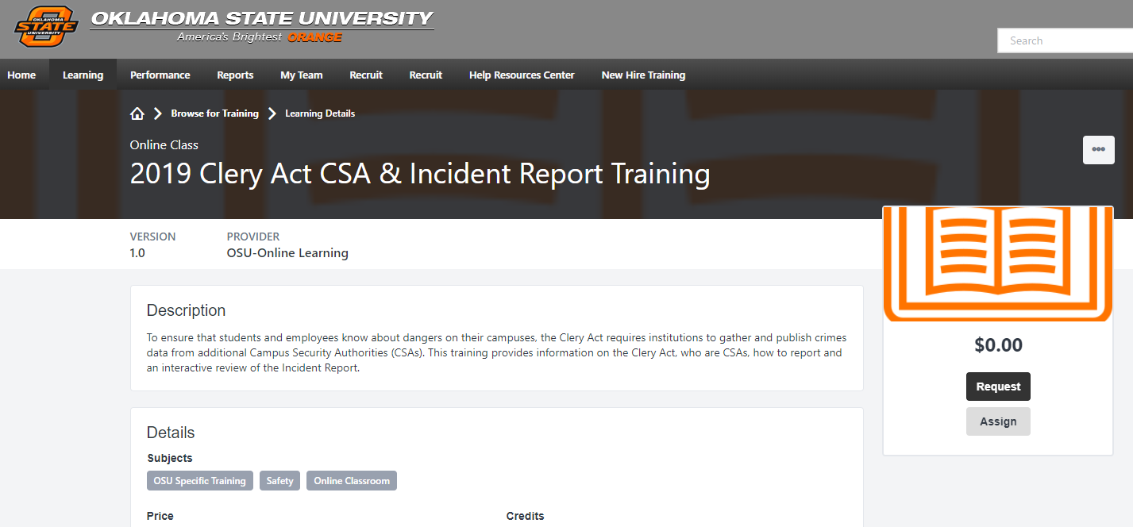

- To assign the course, scroll down until you find the Direct Subordinates section and select which employees you would like to enroll by clicking the box next to their name. Click Submit when finished.
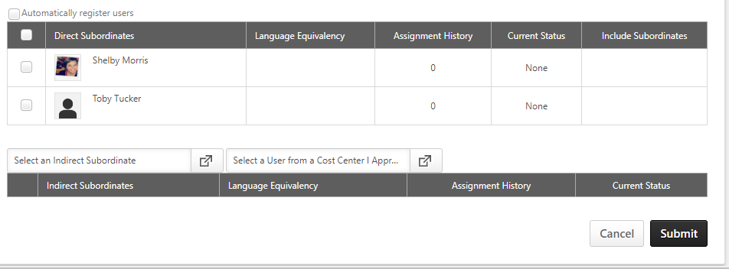
NOTE: In the Direct Reports section, a list of the manager’s direct reports and any users for whom they are the approver display. By default, no users are displayed in the Indirect Reports table.
- An email notification will be sent to the Learners notifying them of the course.

2) How to Do A Quick Status Check
My Team
You can view a snapshot of each individual team member by selecting My Team from the My Team drop down menu.
- Select the team member by clicking on their name.
LEARNER NAME
LEARNER NAME
LEARNER NAME
- The report defaults to Archived Activities. Select Current Activities to review the status of activities not yet completed.

