Download/Installation Guide – Read and Write Gold
These instructions are for students wanting to download this software to their computer

- Click link https://www.texthelp.com/en-us/products/read-write/read-write-for-education/

- Click “Try Read&Write” today and select your platform. For this example “Windows” was selected and US English

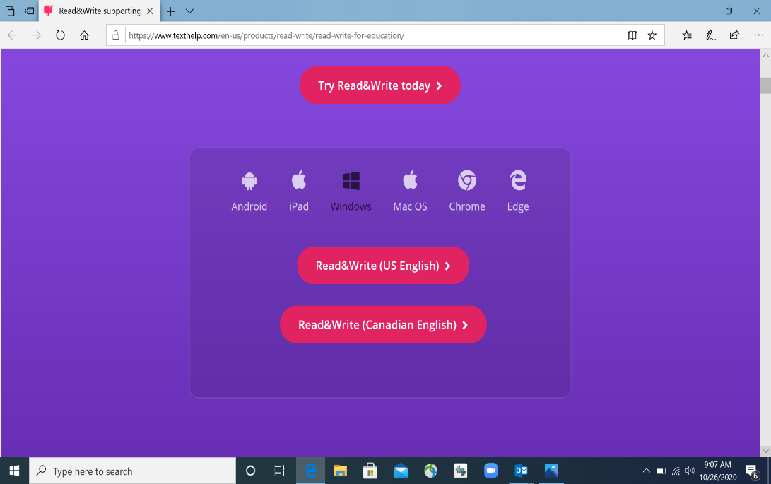

- Download software and follow installation instructions.

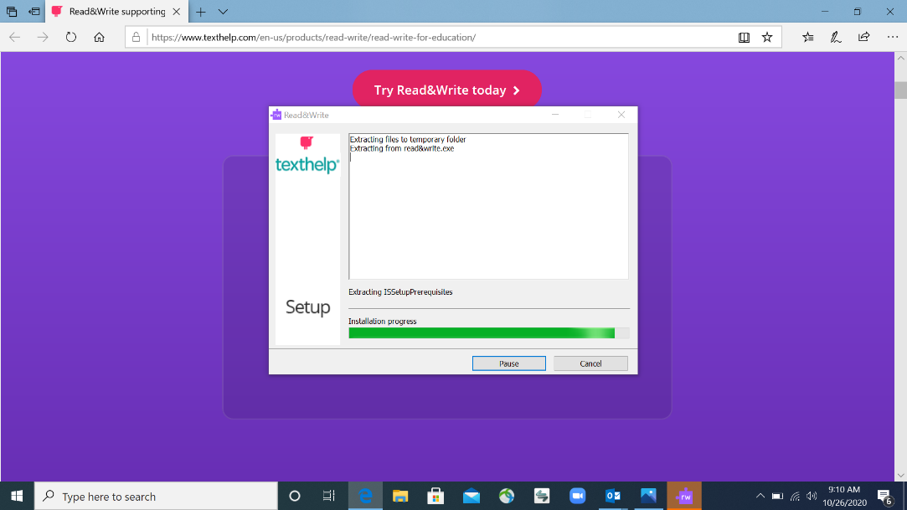

- Click “Accept and Install”

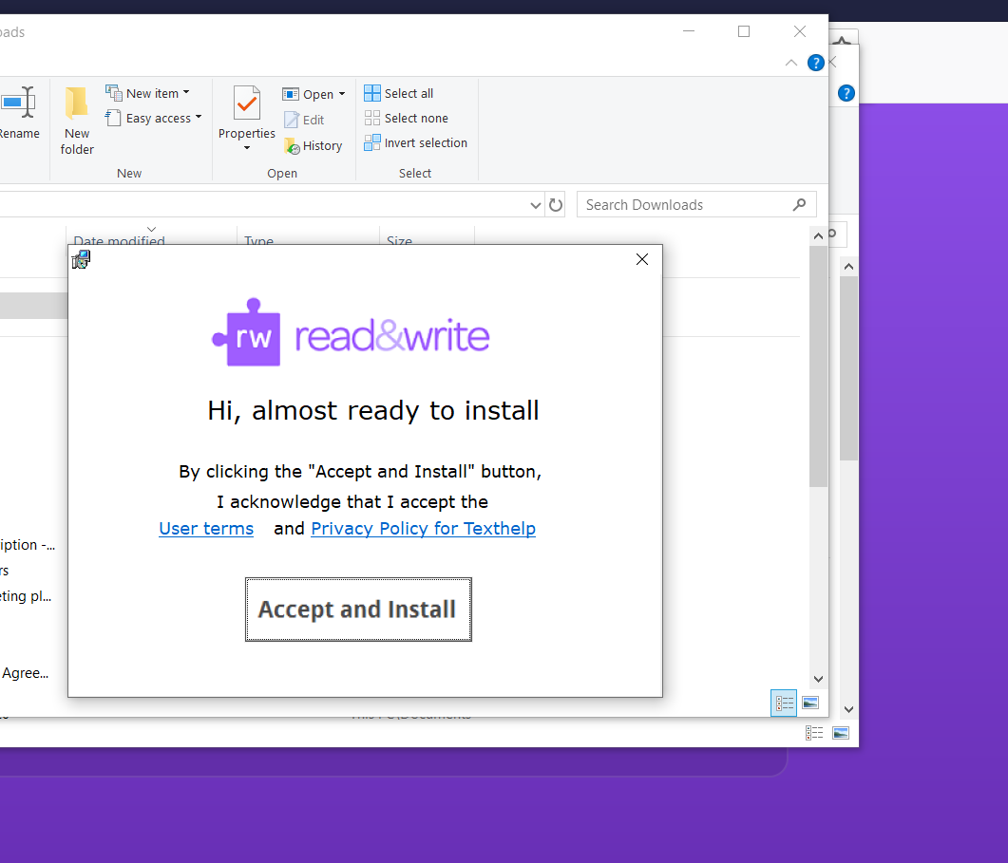

- Once installed, open the program. Double click this icon on your desktop.

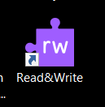
IMPORTANT: Once you have opened Read and Write Gold you must sign-in before using it.

- Sign-in to Read and Write Gold by clicking the icon on the right-hand side of the toolbar

- Select “Sign-in with Microsoft.” Sign-in with your O-Key username and password.

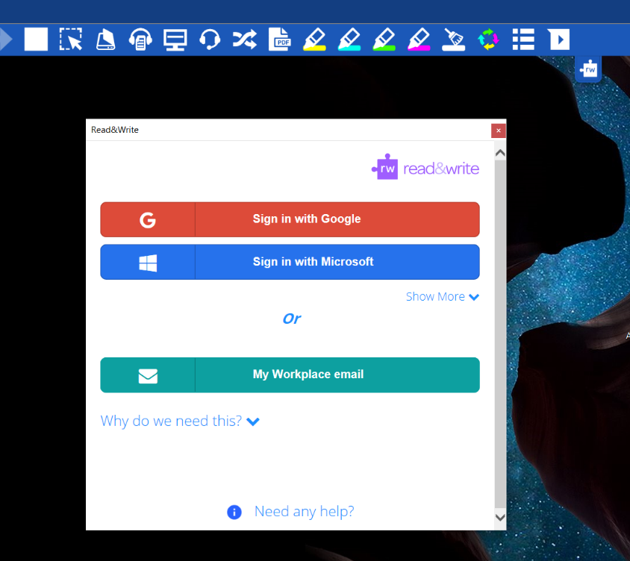

Congratulations! You are now ready to use Read and Write.

